Secure Network Infrastructure with OPNsense – Project Report

# Introduction

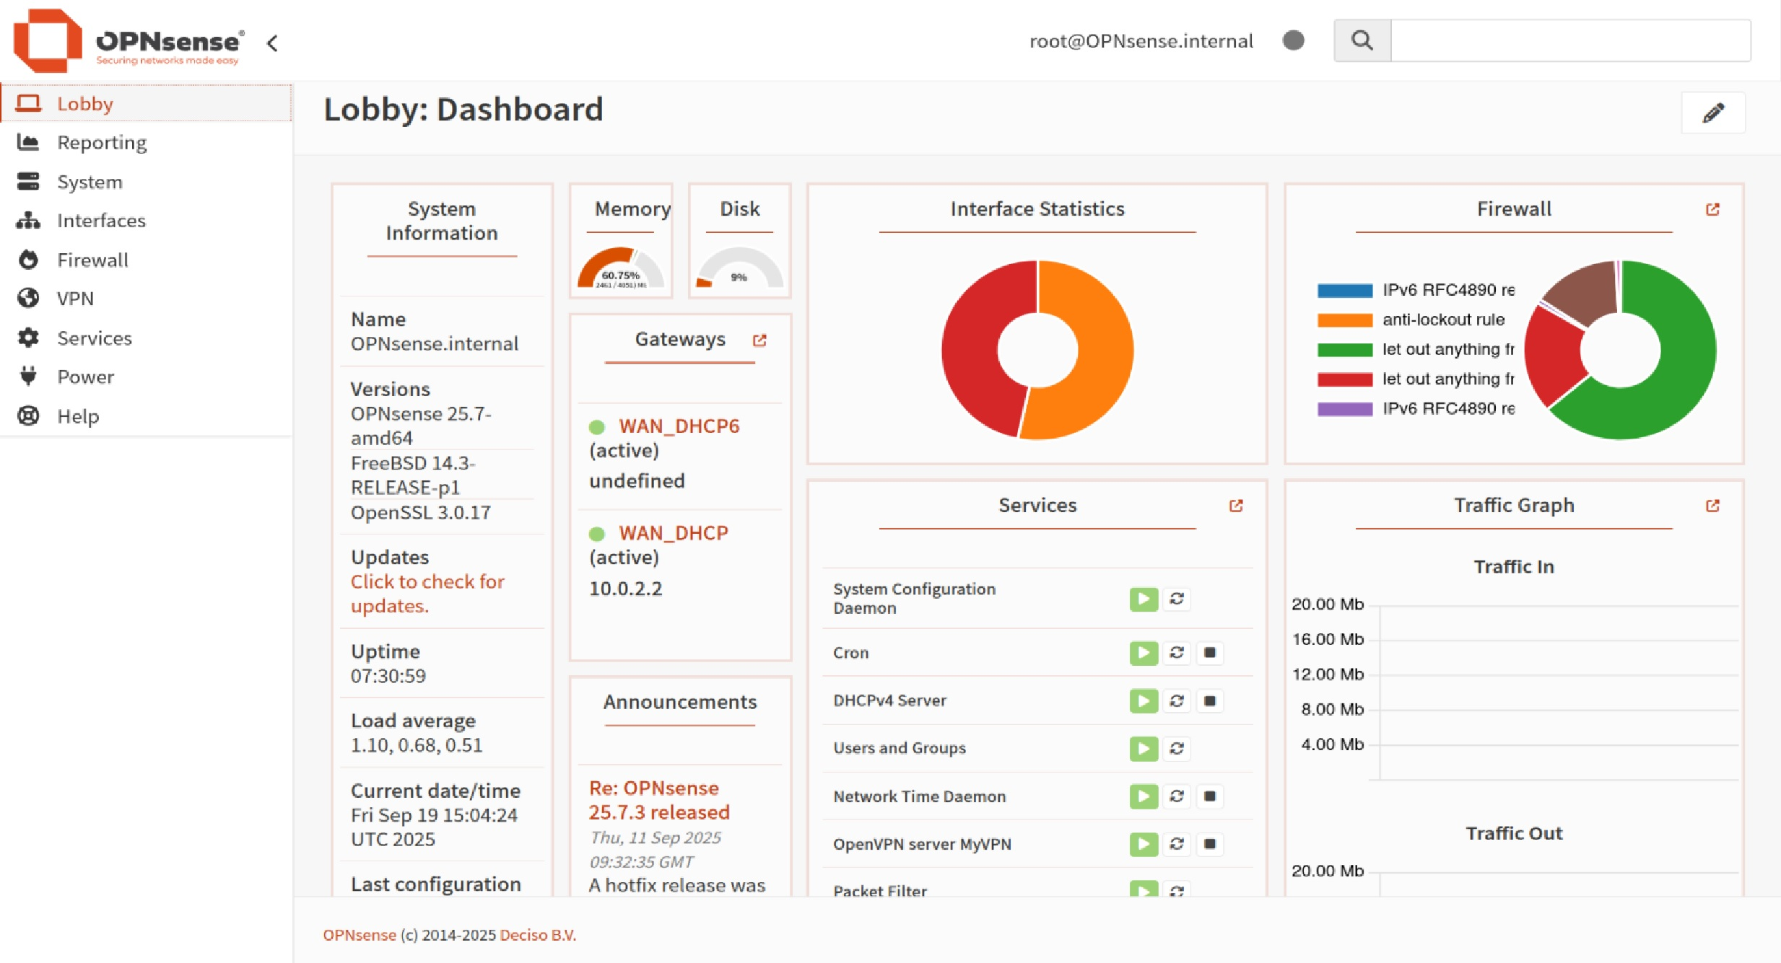

This project simulates a full-fledged secure corporate network architecture based on OPNsense — one of the most reliable and flexible open-source firewalls available. The solution covers critical aspects of cybersecurity: network segmentation, traffic filtering, intrusion detection and prevention, and encrypted remote access. Every configuration step was carefully planned and implemented to reflect real-world security practices.

# Lab Architecture

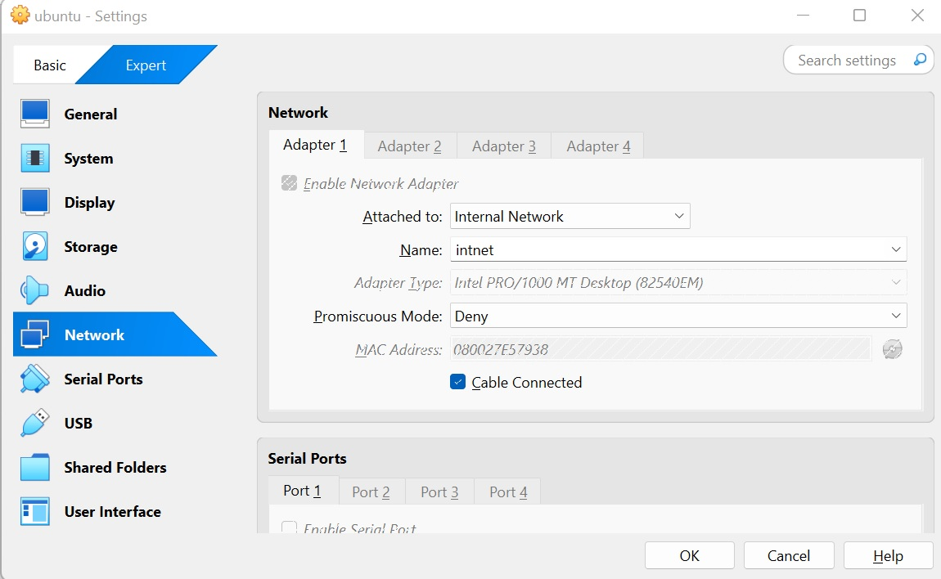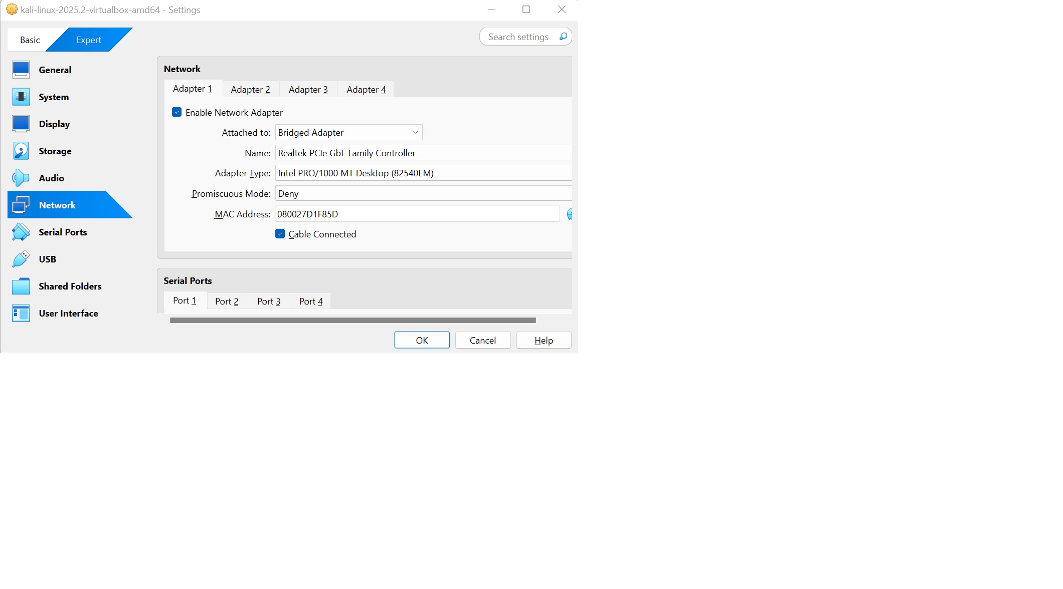

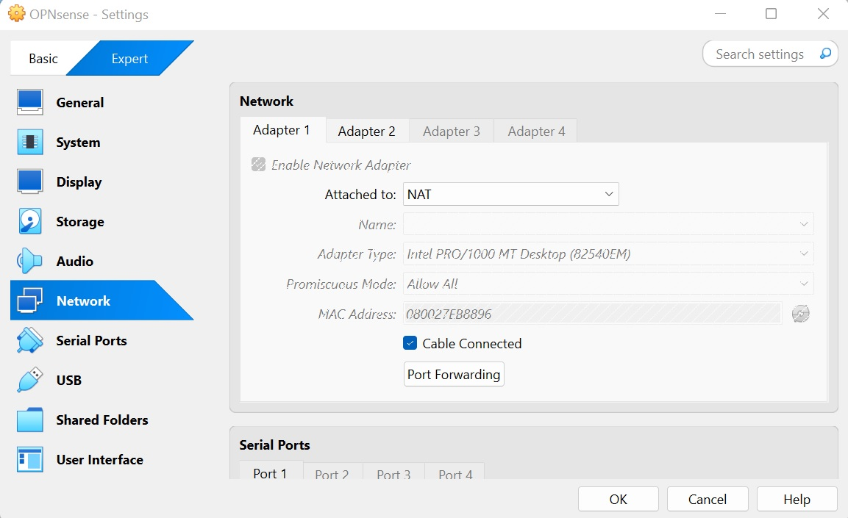

The lab was deployed in VirtualBox and includes three virtual machines:  
  
• OPNsense — the security core: acts as firewall, DHCP, NAT, IDS/IPS and VPN gateway.  
• Ubuntu Server — target host (LAN/DMZ) for attack simulations and penetration testing.  
• Kali Linux — attack machine simulating both internal and external threats.  
  
This setup replicates the basic structure of a real-world small or mid-size business network from a security perspective.

# IP Plan & Logical Segmentation

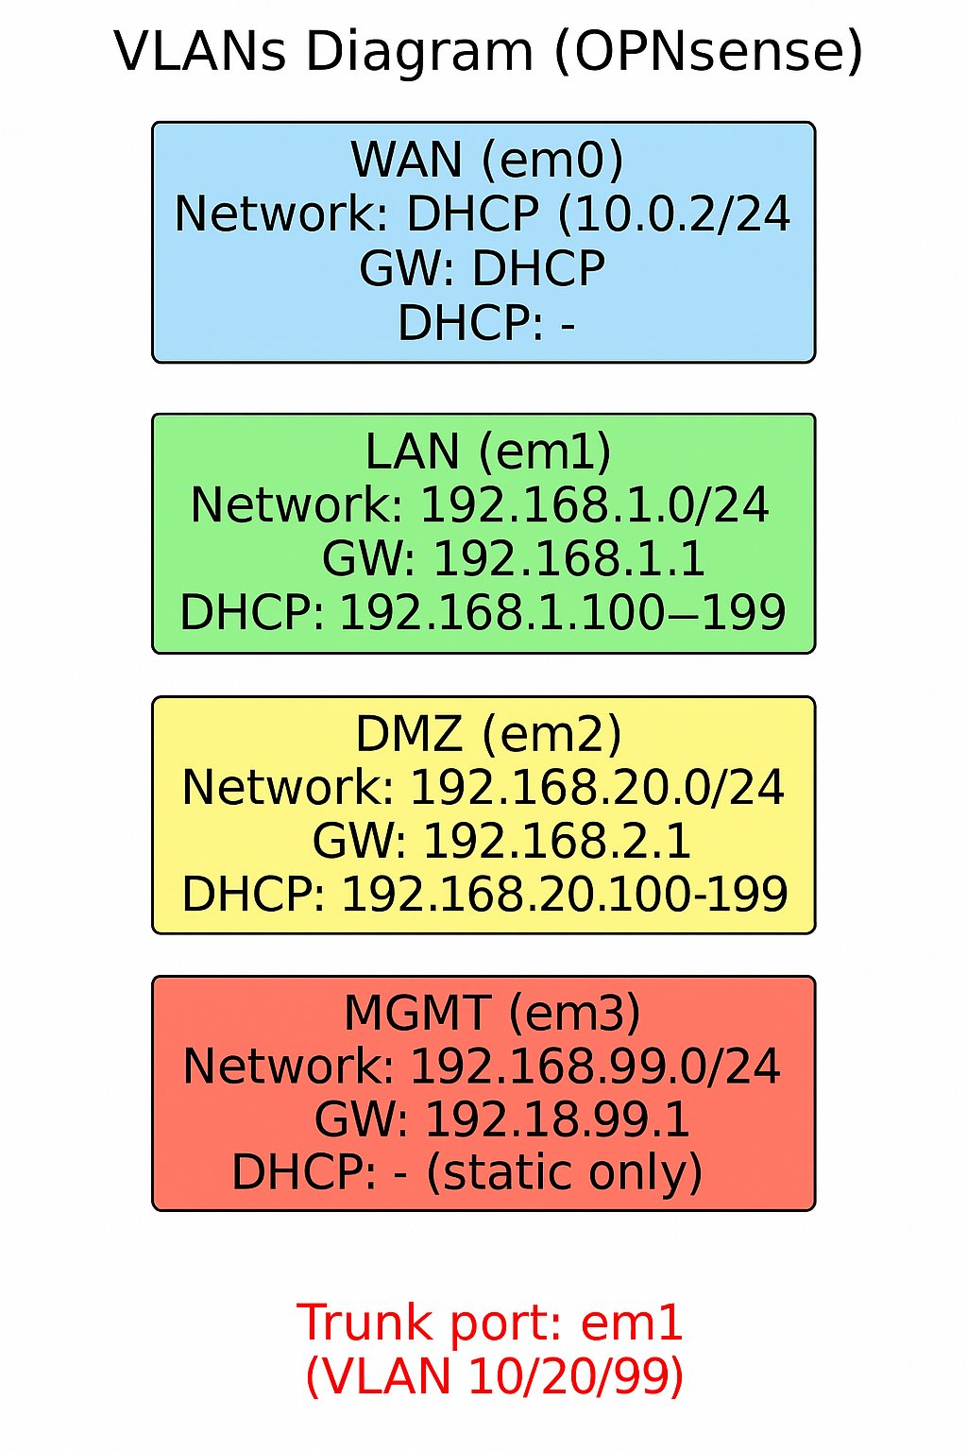

The IP structure is clearly planned and segmented:  
  
• WAN — external internet access (via NAT).  
• LAN — internal user and service zone (192.168.1.0/24).  
• DMZ — exposed zone for public-facing services (192.168.20.0/24).  
• MGMT — isolated management segment (192.168.99.0/24).  
  
VLANs were configured using 802.1Q tags, providing a professional level of logical separation.

# OPNsense Interface Configuration

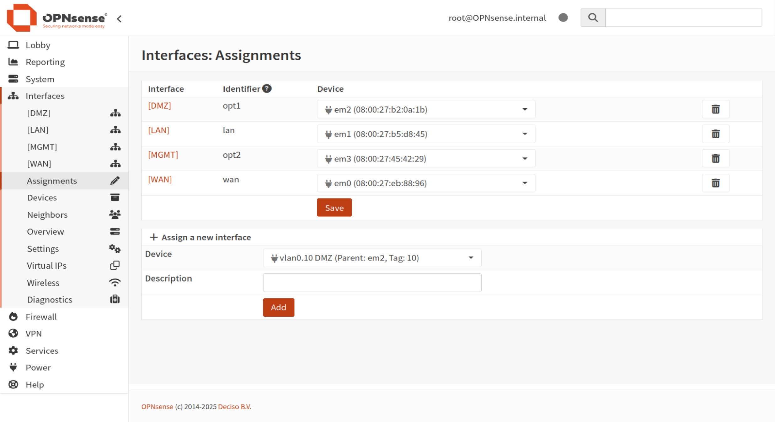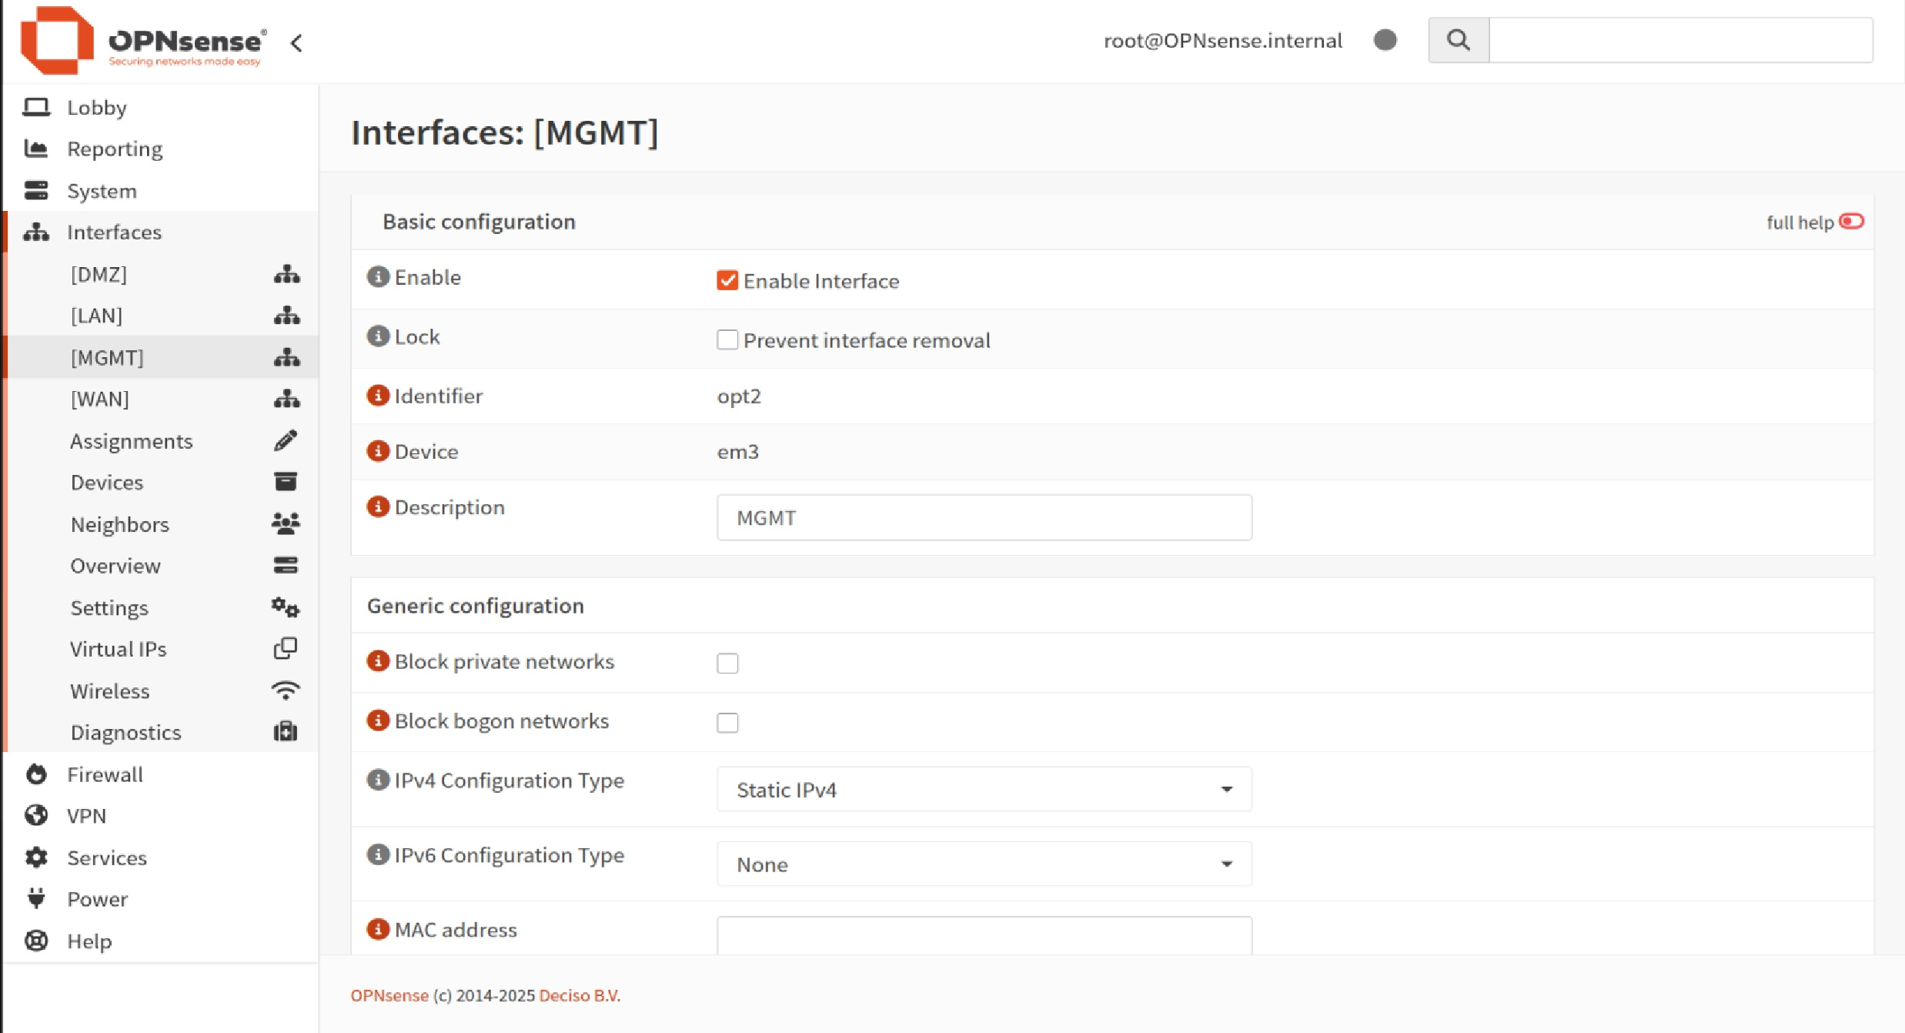

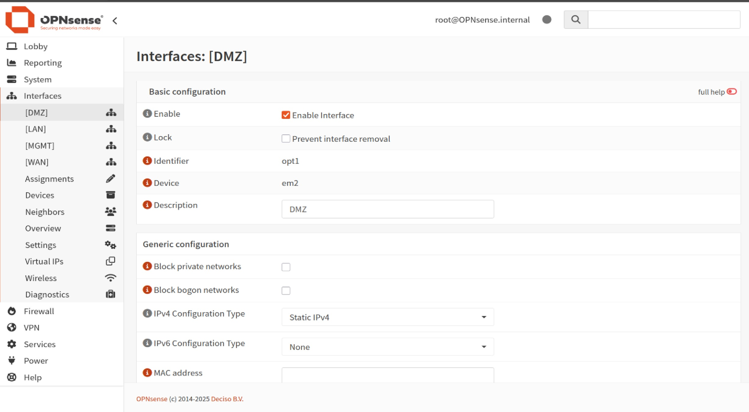

Each interface received a specific role and IP address. Key security controls were applied:  
• Bogon and private IP filtering on MGMT and DMZ interfaces.  
• Static IPs set and VLAN isolation applied.  
• Strict routing rules implemented between zones.

# 5. DHCP Server Setup

DHCP (ISC DHCPv4) was enabled on internal interfaces:  
• LAN: 192.168.1.100–199  
• DMZ: 192.168.20.100–199  
• MGMT: 192.168.99.100–199  
  
Reserved ranges and DNS/gateway options were configured to ensure control and flexibility.

# 6. Firewall & Security Model

A strict, zone-based firewall model was implemented using the **"deny by default"** principle. Each network segment (LAN, DMZ, MGMT) has its own rule set designed to isolate traffic, reduce the attack surface, and enforce least privilege. The configuration is enhanced through the use of address aliases and GeoIP filtering, ensuring both control and scalability.

### LAN (User Network)

Outbound access to the internet is **strictly limited** to:

DNS (port 53)

HTTPS (port 443)

All other traffic is **blocked** by default.

No inbound connections are allowed to the LAN zone.

This setup reduces exposure to external threats and limits internal misuse.

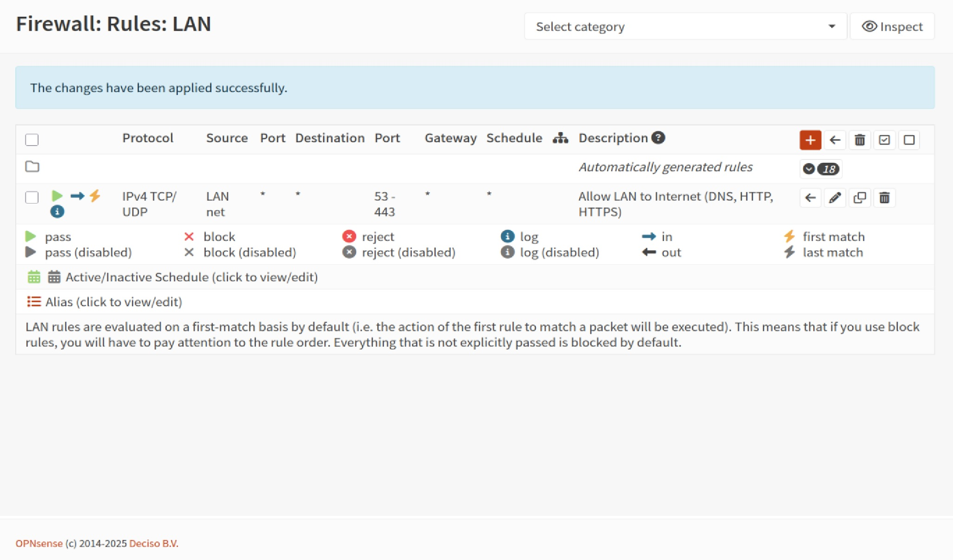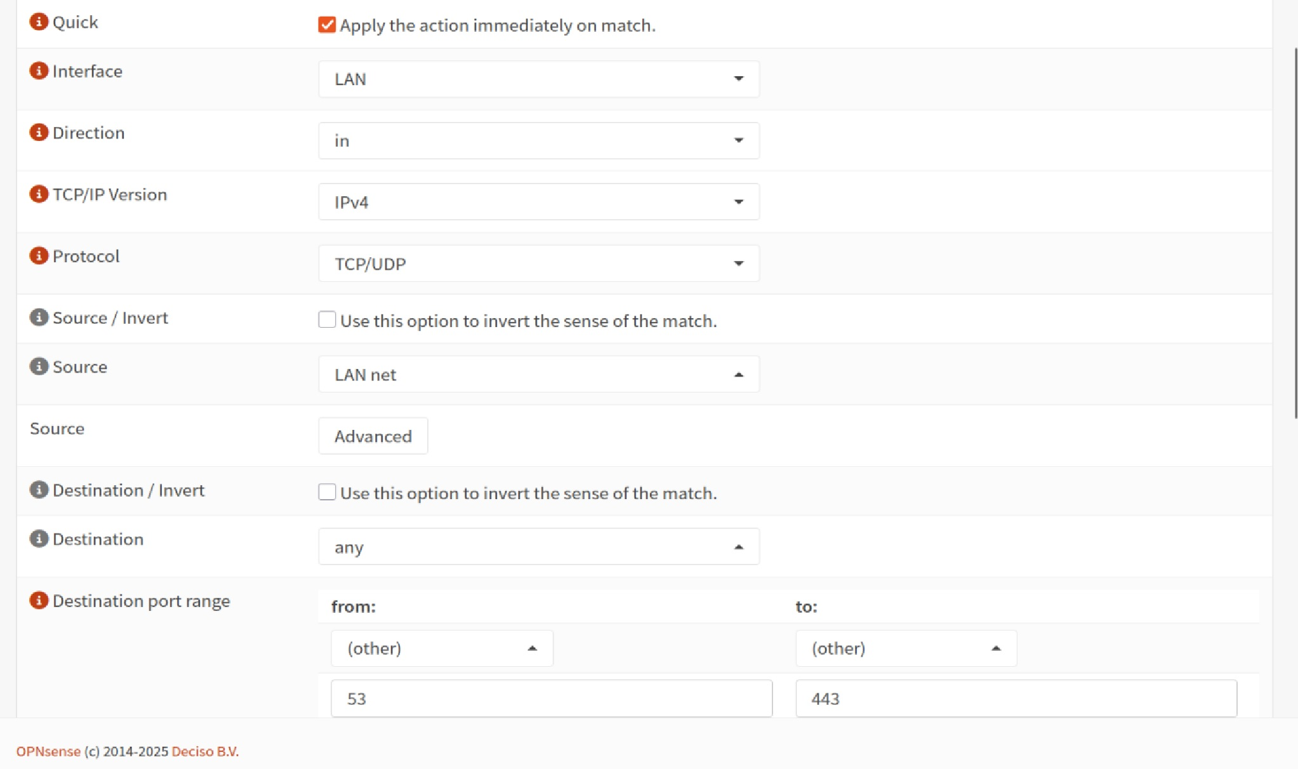

### DMZ (Demilitarized Zone)

Only outbound traffic is allowed from DMZ to:

HTTP (port 80)

HTTPS (port 443)

**All access from DMZ to LAN or MGMT is explicitly denied**.

Public services (like web servers) can operate without compromising internal systems.

This configuration isolates exposed services from sensitive segments.

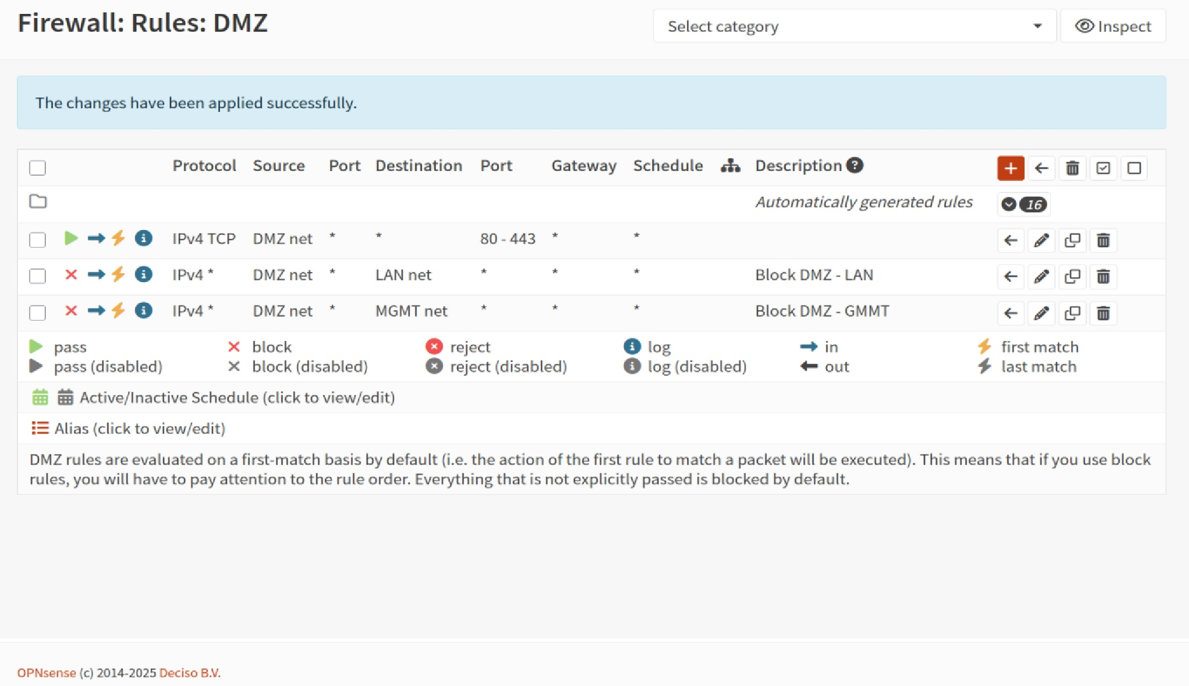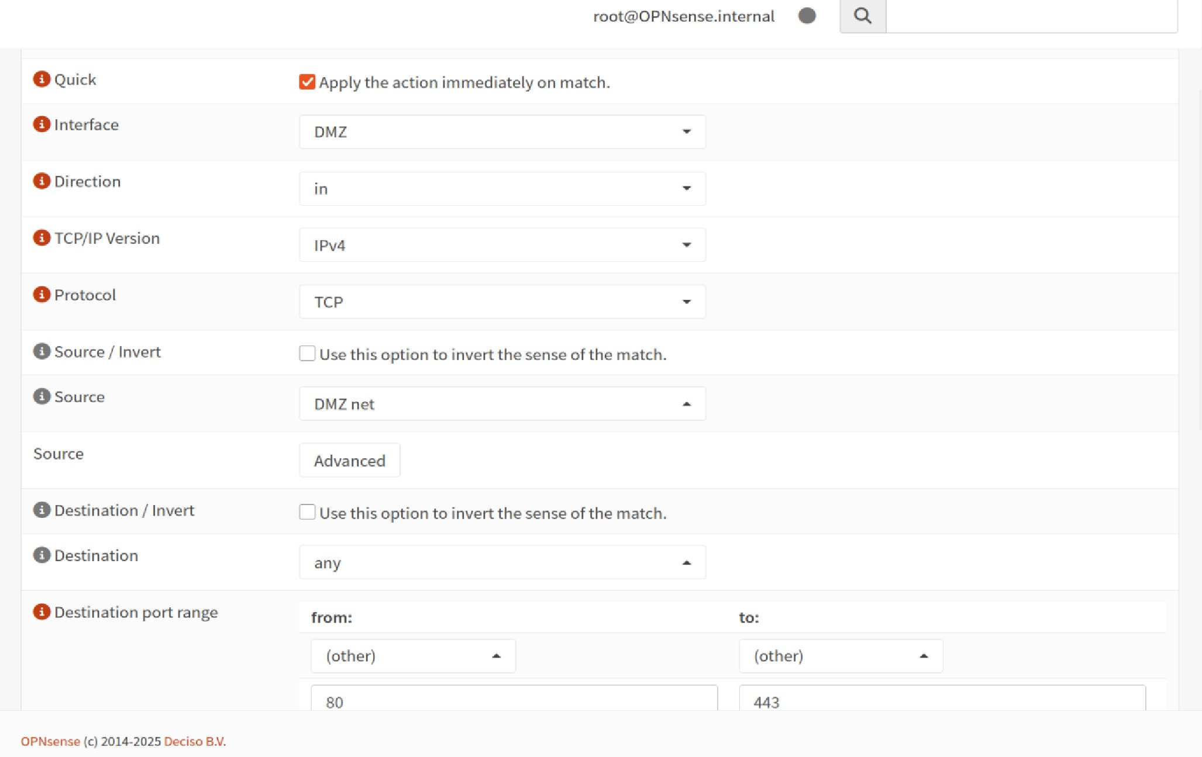

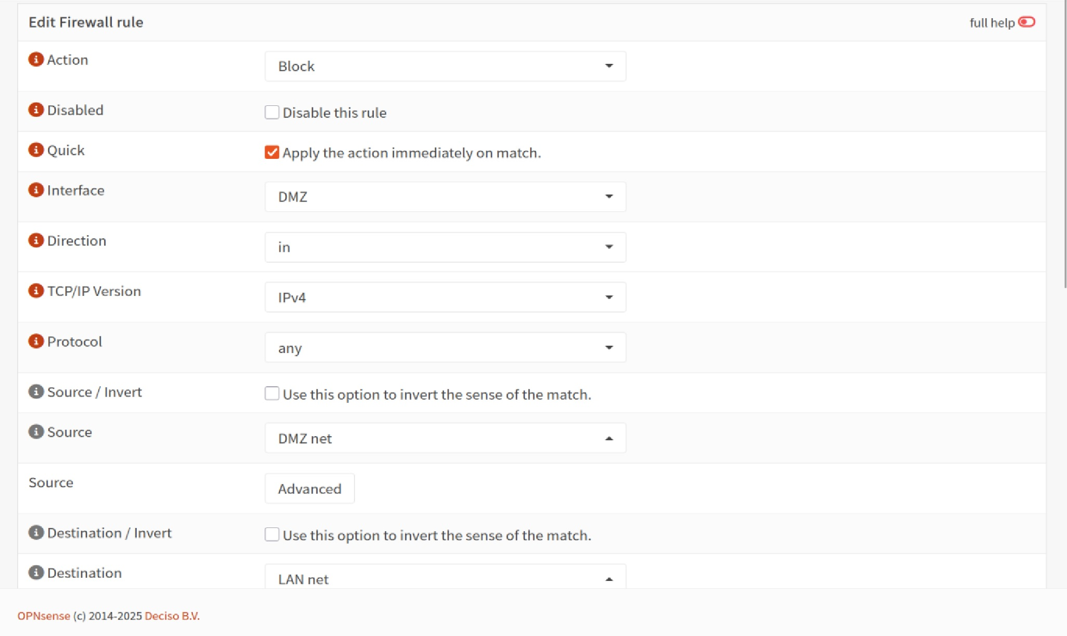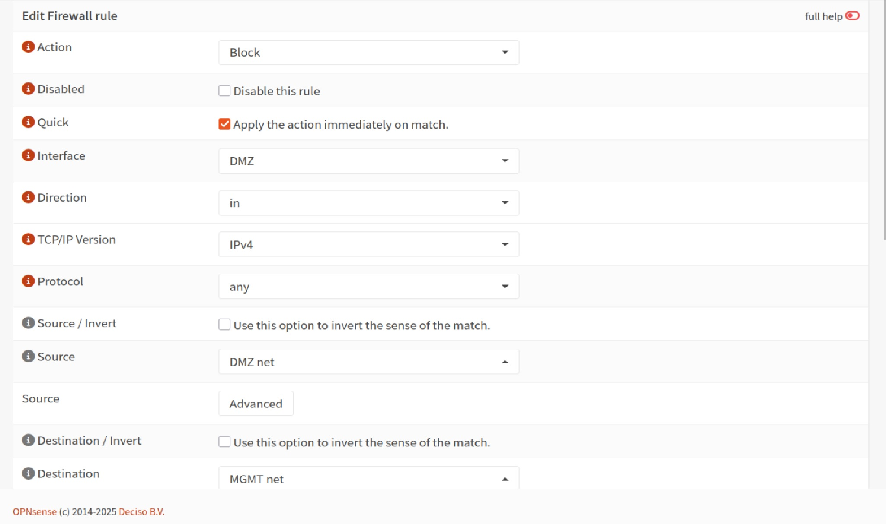

### MGMT (Management Zone)

Only a single trusted IP (192.168.99.10) is allowed access to:

Web GUI (port 443)

SSH (port 22)

All other connections are **blocked completely**.

This ensures that management access is strictly limited and not exposed to internal or external treats.

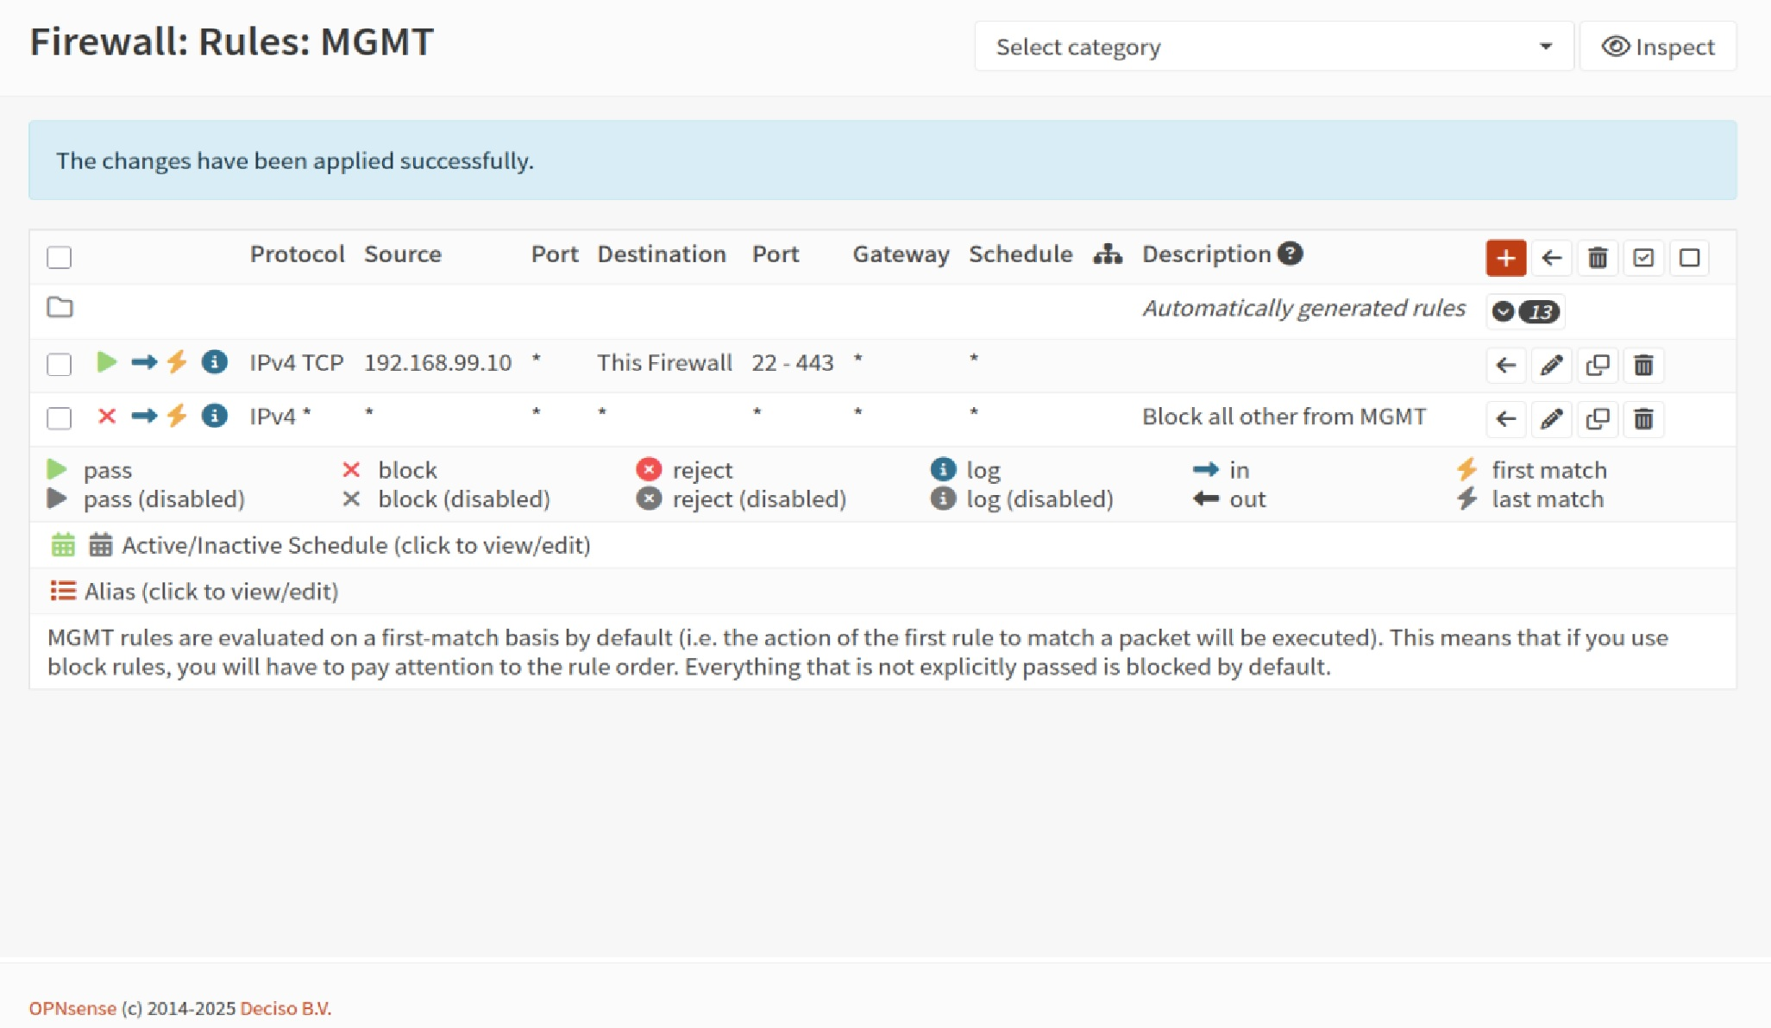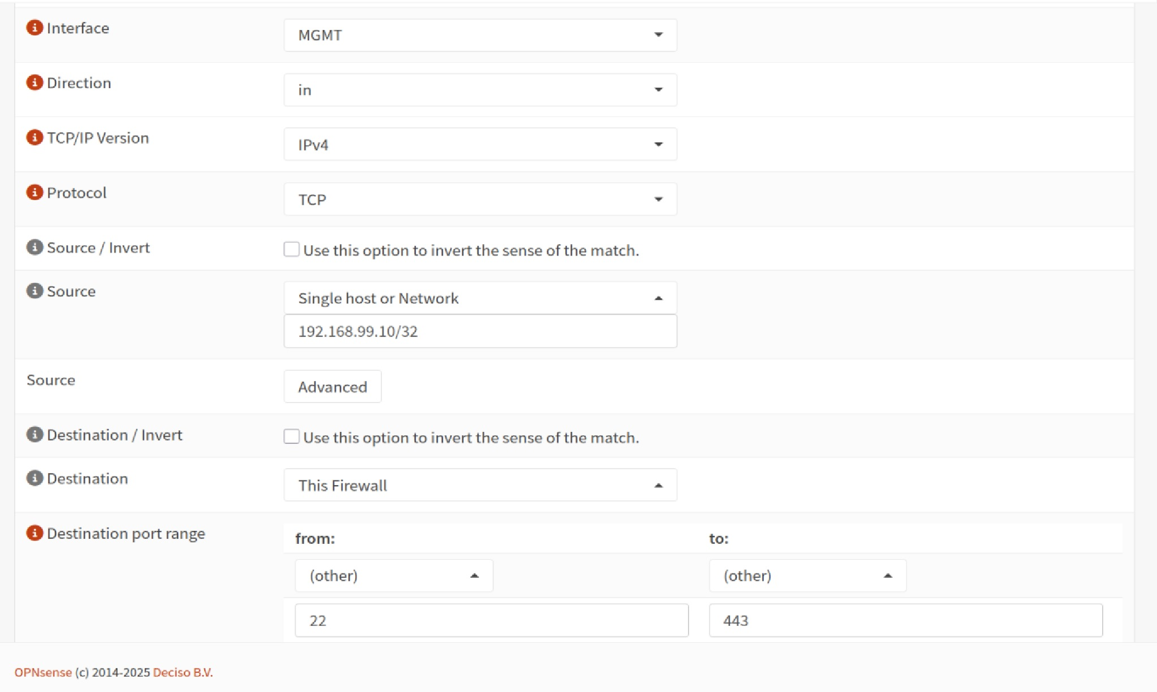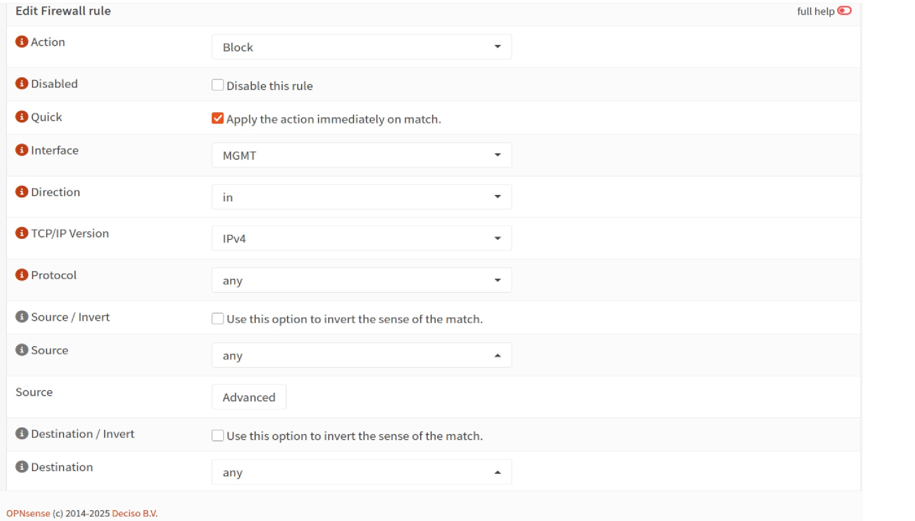

### Aliases

Aliases were used to simplify rule creation and enhance maintainability:

Servers — represents a group of internal servers (LAN/DMZ).

Trusted_Admins — IPs allowed to access the firewall GUI/SSH.

Blocked_Countries — GeoIP alias containing countries such as:

China, Iran, Russia, Vietnam, Bangladesh, and others.

Using aliases makes the rulebase more readable and easier to manage.

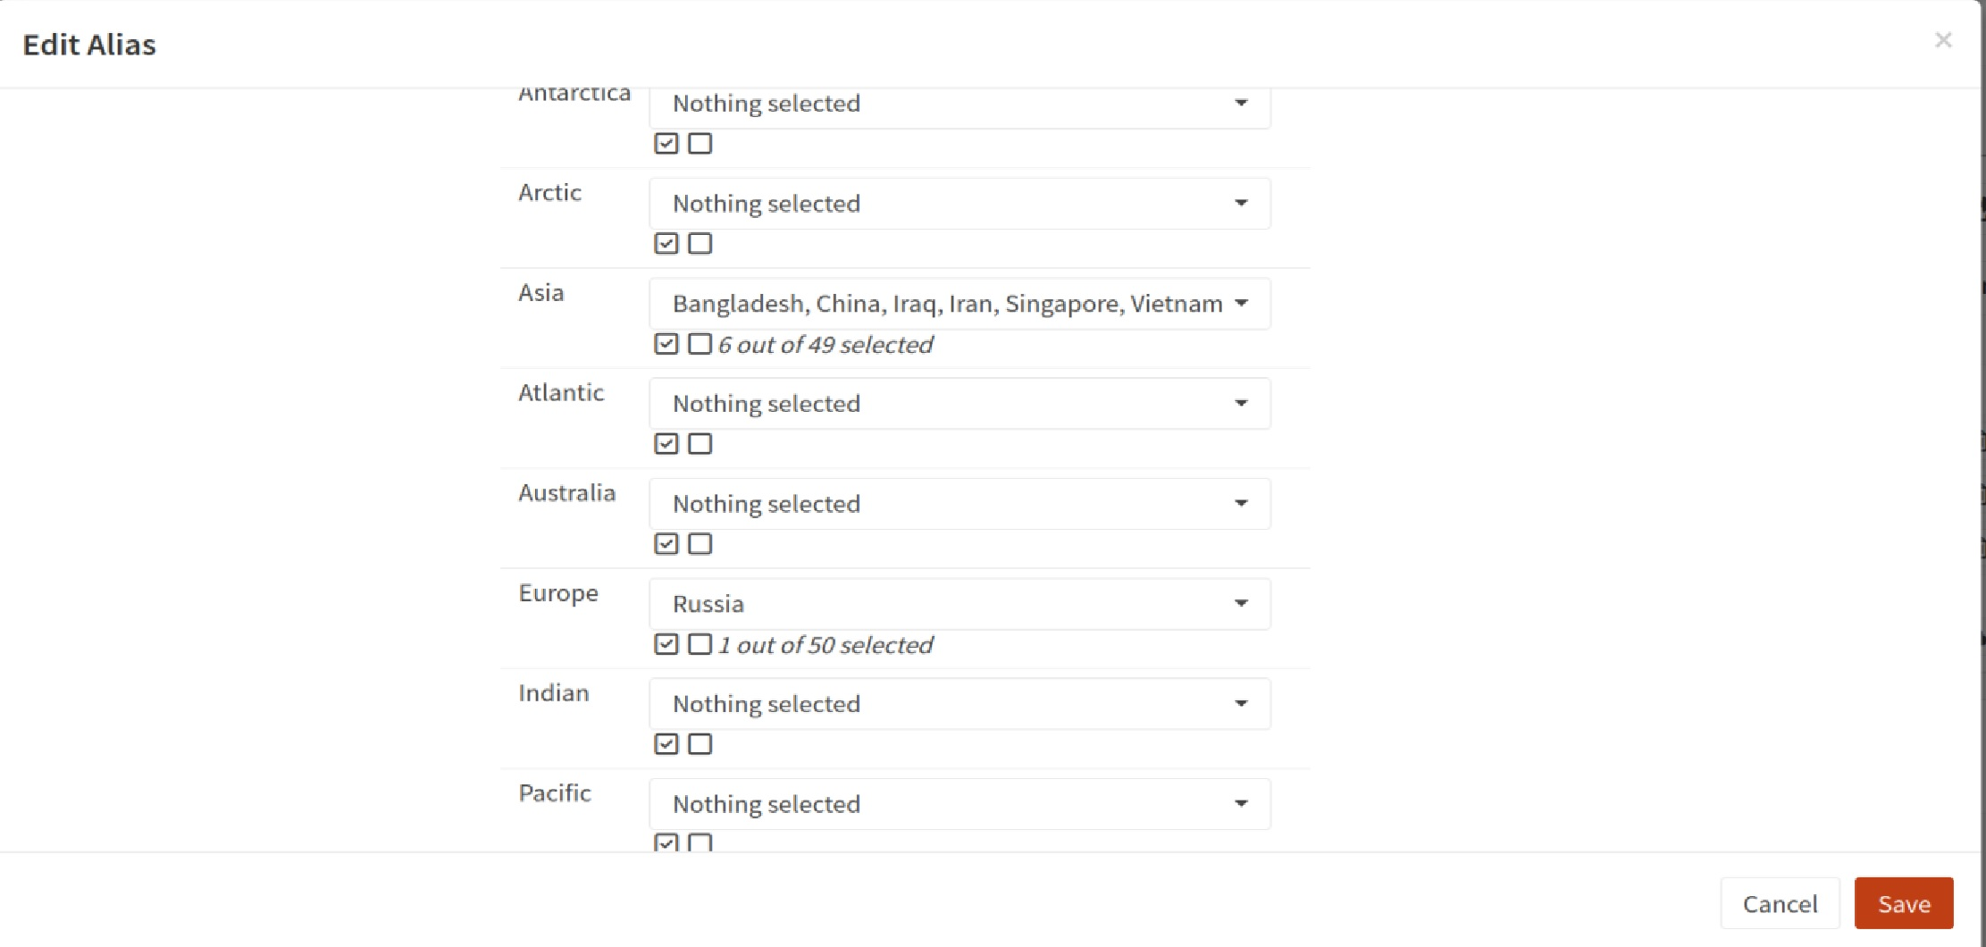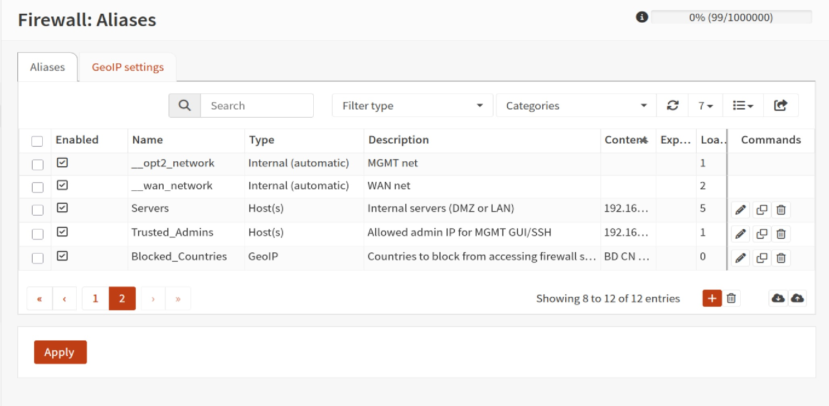

### NAT (Outbound)

**Automatic outbound NAT** is enabled.

All traffic from internal zones is translated to the WAN interface IP.

This allows secure internet access while preserving internal address privacy.

Ideal for small/medium network environments where simplicity and security are both required.

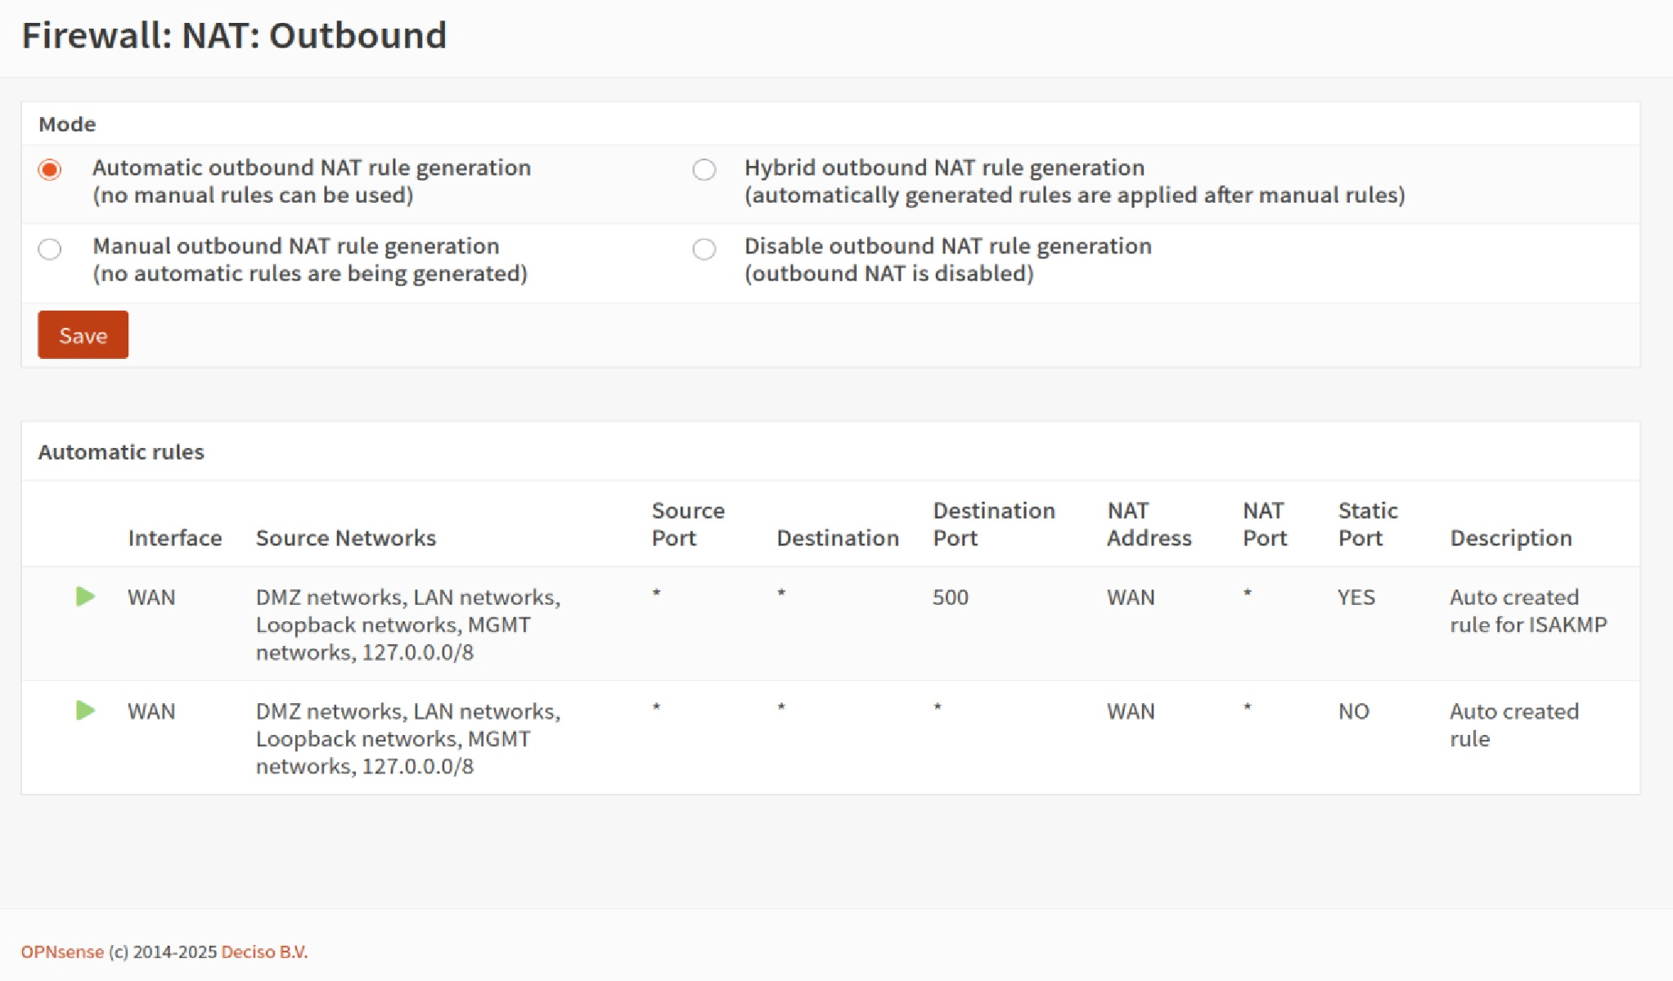

# 7. Intrusion Detection & Prevention (Suricata)

Suricata IDS/IPS was deployed with the following configuration:  
• IPS mode enabled for automatic threat blocking.  
• Monitors WAN, LAN, and DMZ interfaces.  
• Uses updated rule sets from Feodo Tracker, ThreatFox, and other feeds.  
• Logs are stored and ready for export to SIEM for further correlation.

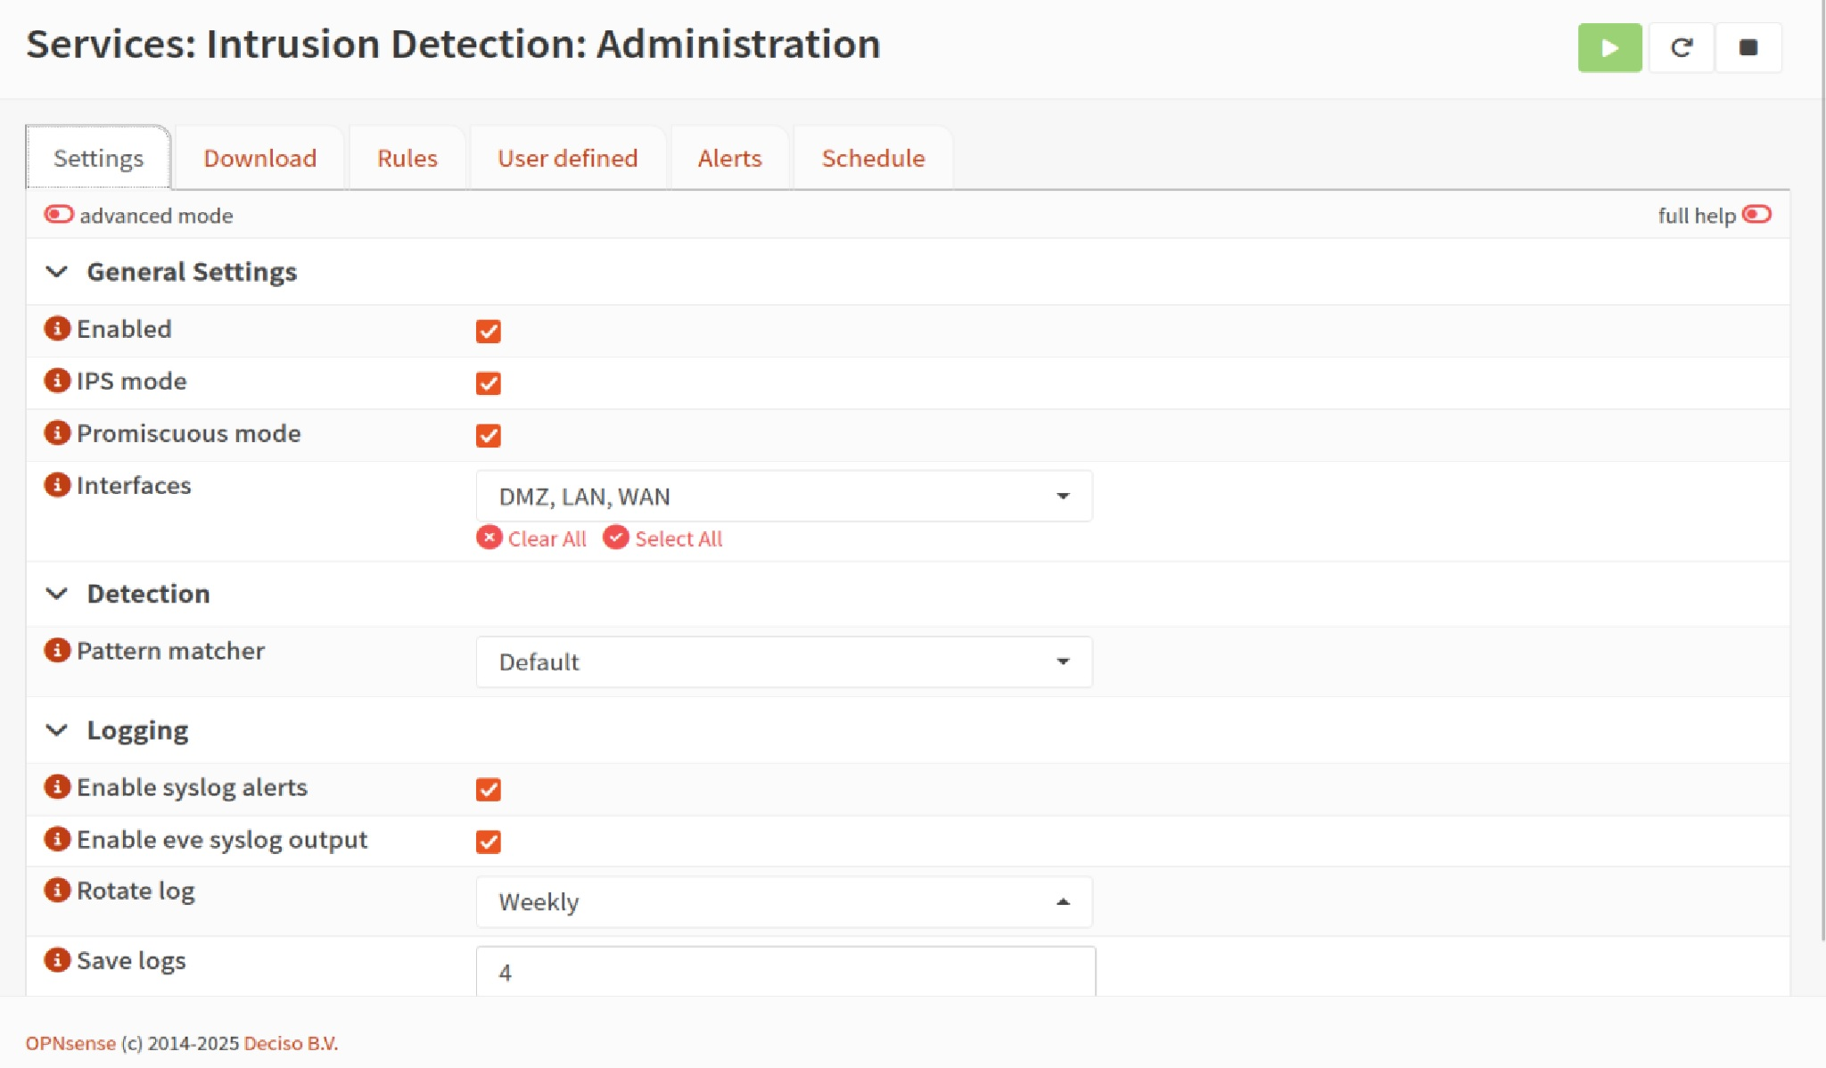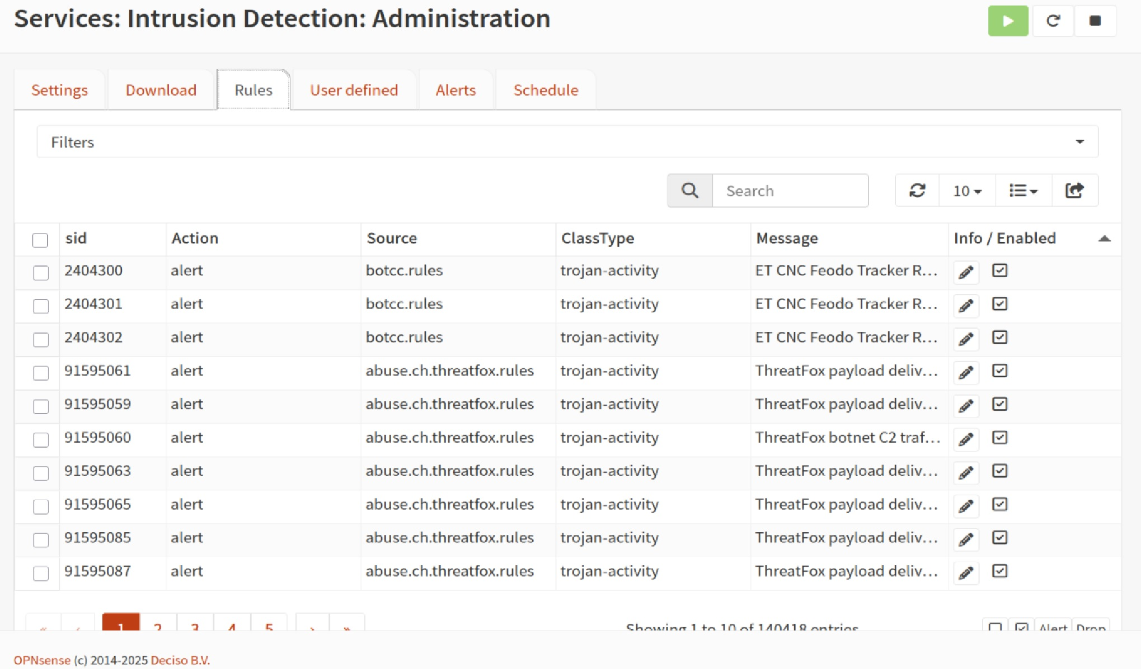

# 8. VPN Access (OpenVPN)

As part of the project, a fully functional **OpenVPN** remote access server was deployed using OPNsense. The goal was to provide **secure encrypted remote access** to the internal infrastructure through a private VPN tunnel.

The setup included the following key steps:

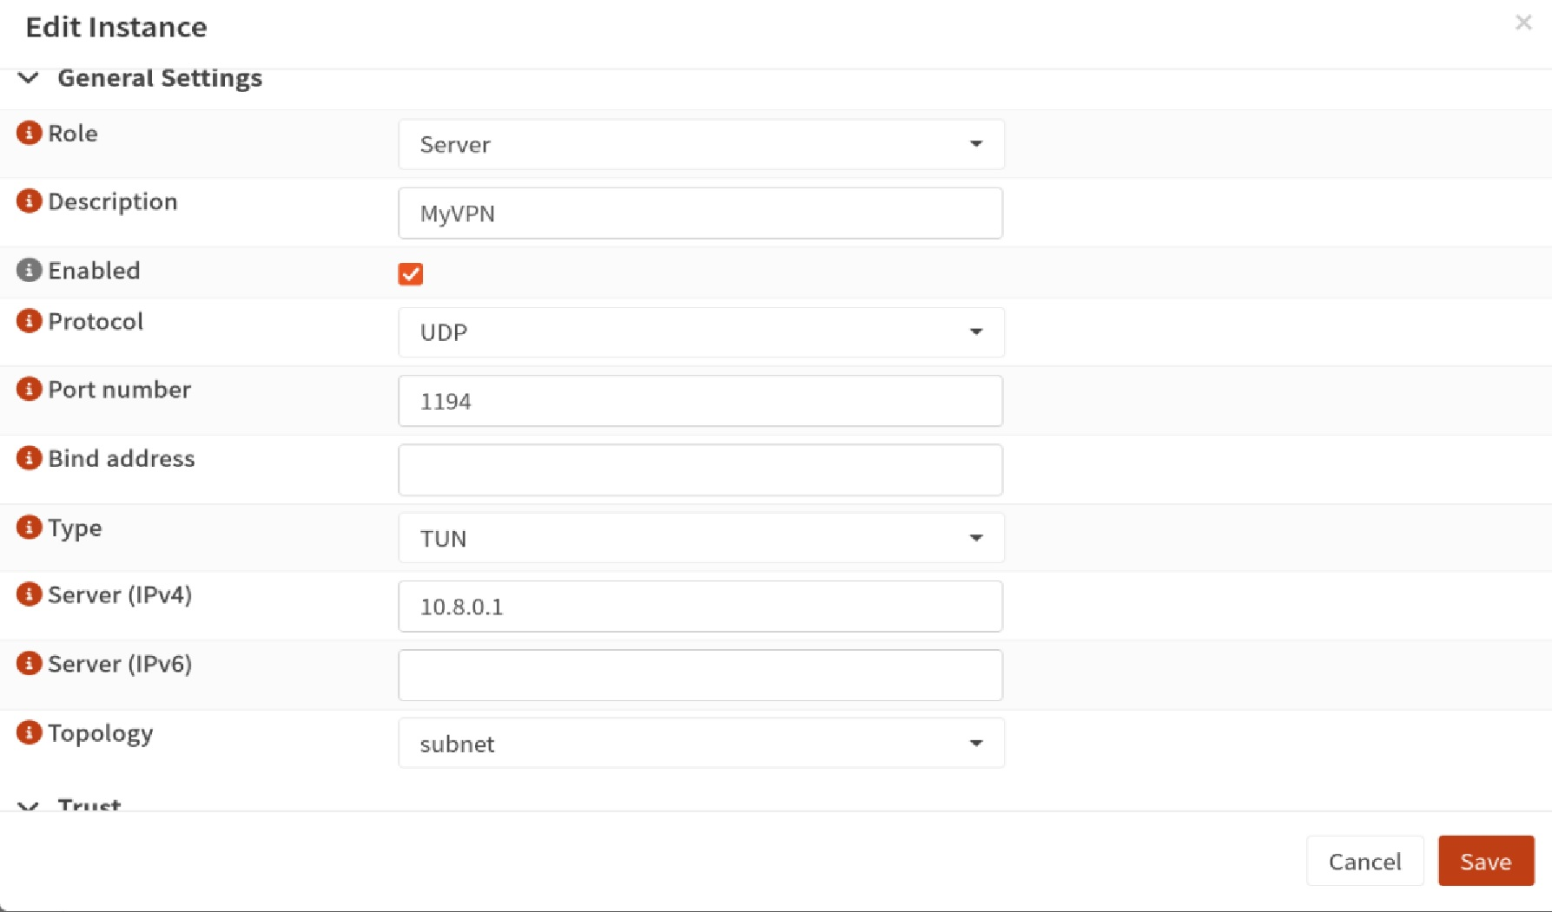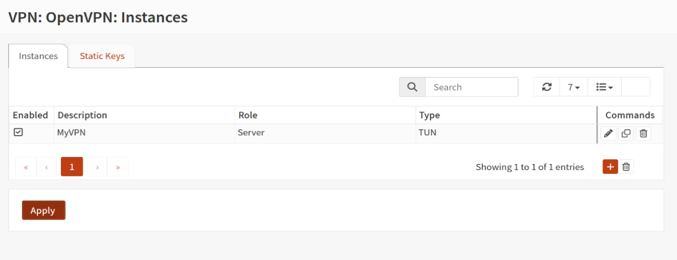

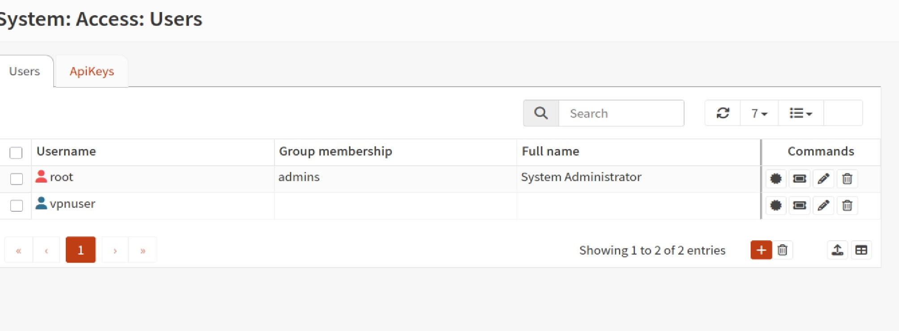

### 1. Creating a Certificate Authority (CA)

**Path:** System → Trust → Authorities

A **self-signed certificate authority** named VPN_CA was created.

Certificate validity: **10 years** (2025–2035).

CA metadata:

Country: **Netherlands**

State/Province: **Zuid-Holland**

City: **Rotterdam**

This CA is used to sign all VPN-related certificates.

### 2. Creating a Server Certificate

**Path:** System → Trust → Certificates

A certificate named OpenVPN_Server_Cert, signed by VPN_CA.

Parameters:

Type: **Server Certificate**

Algorithm: **RSA-2048**

Digest: **SHA256**

Validity: ~1 year

This certificate is used on the OpenVPN server side for authentication.

### 3. Creating a VPN User

**Path:** System → Access → Users

A user account vpnuser was created.

Added to the admins group for full privileges.

This user was assigned a client certificate and is allowed VPN access.

### 4. OpenVPN Server Configuration

**Path:** VPN → OpenVPN → Servers (Instances)

A server instance named MyVPN was configured:

Role: **Server**

Protocol: **UDP**

Port: -

Interface type: **TUN**

Server IPv4: **10.8.0.1**

Topology: **subnet**

The OpenVPN_Server_Cert was applied here.

This configuration establishes the encrypted tunnel between the client and OPNsense.

### 5. Client Export

**Path:** VPN → OpenVPN → Client Export

Server: MyVPN running on vpn.example.com

An .ovpn configuration archive was generated for the vpnuser.

Includes certificate, key, and all client settings.

Use random local port is enabled (useful for NAT traversal).

Custom option: FORWARD_COMPATIBLE 1.

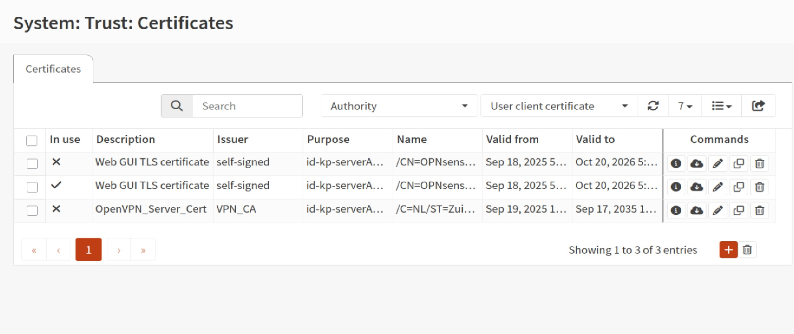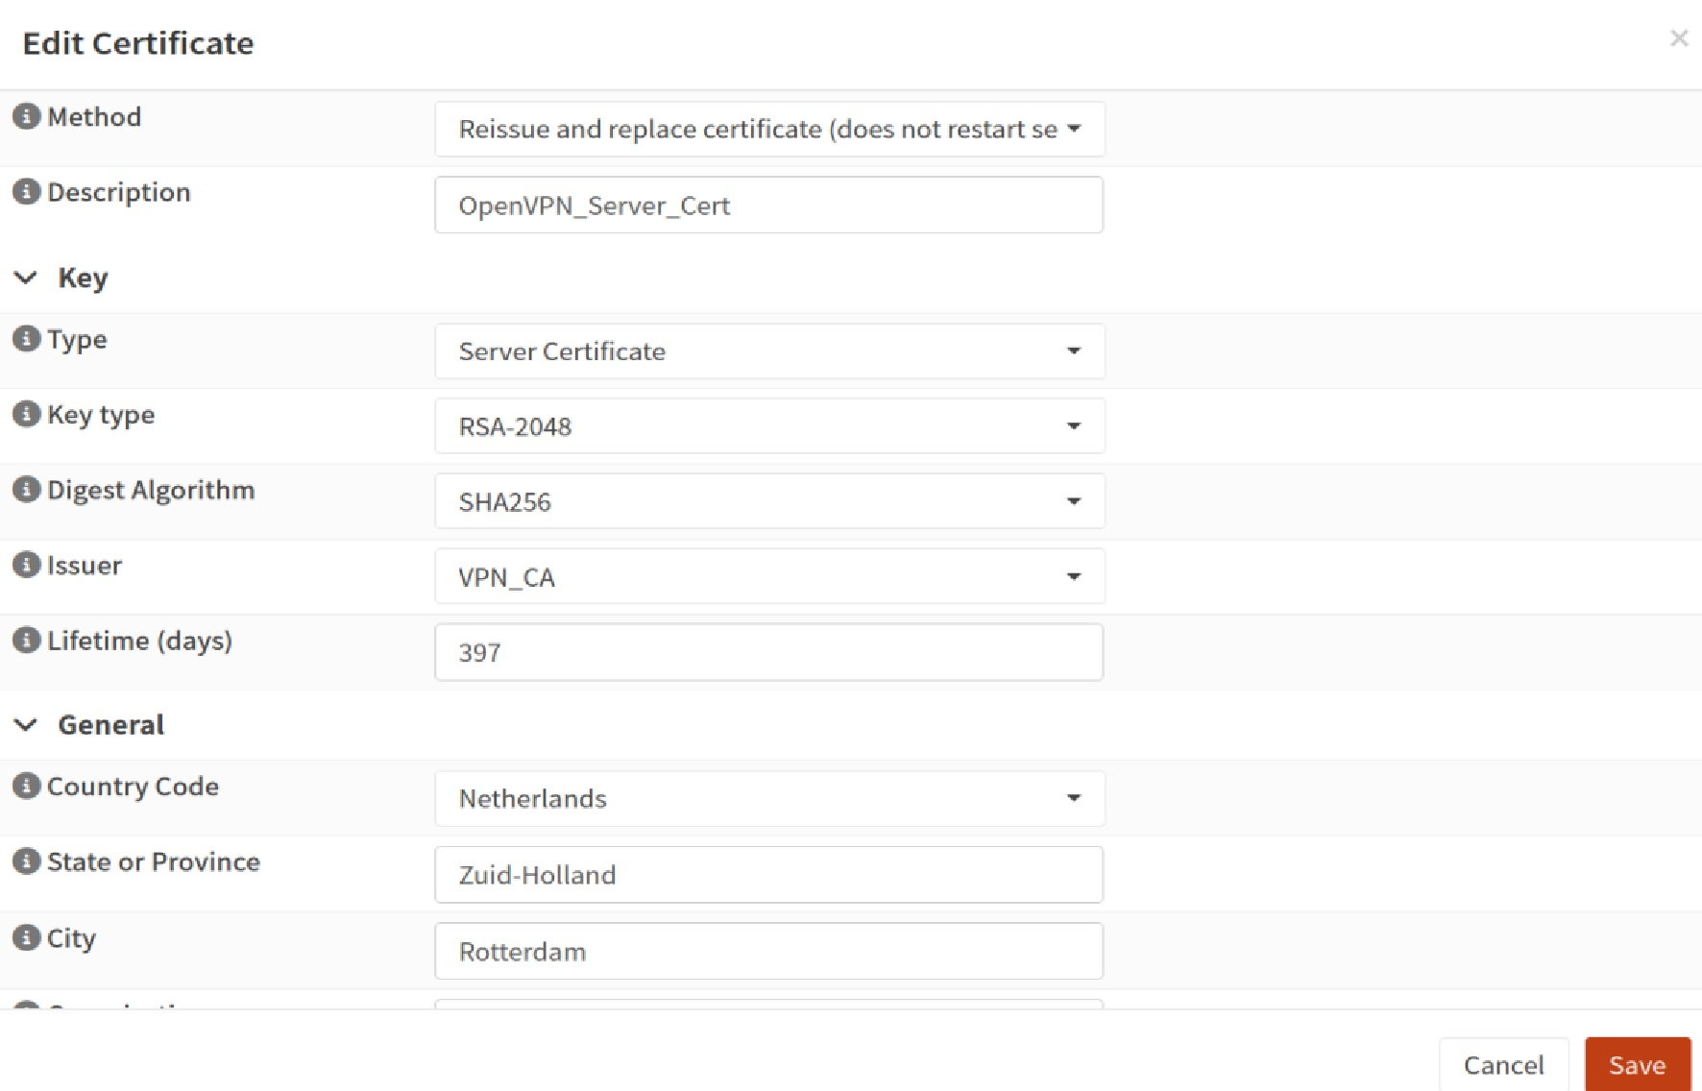

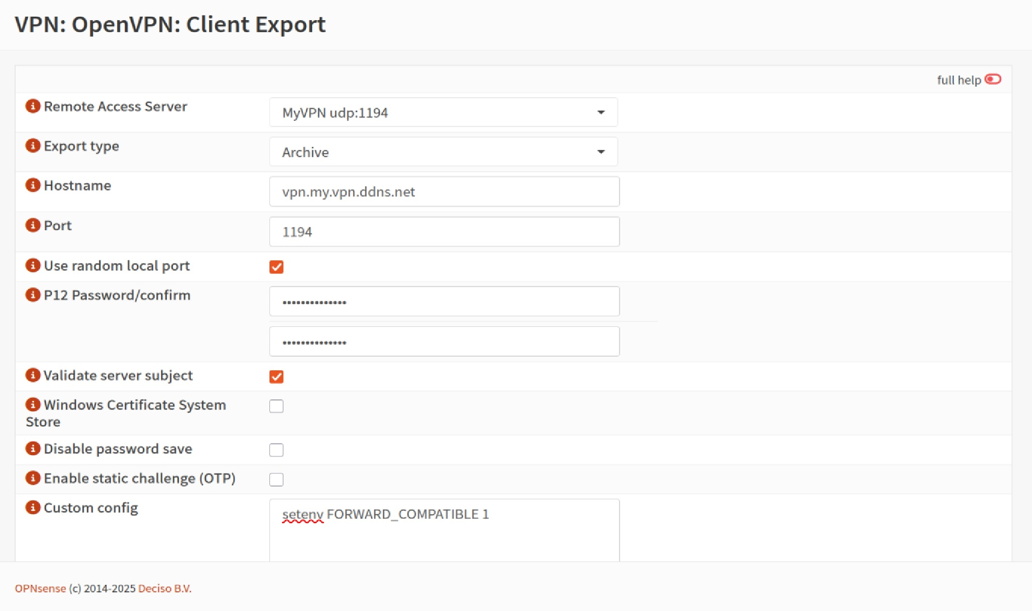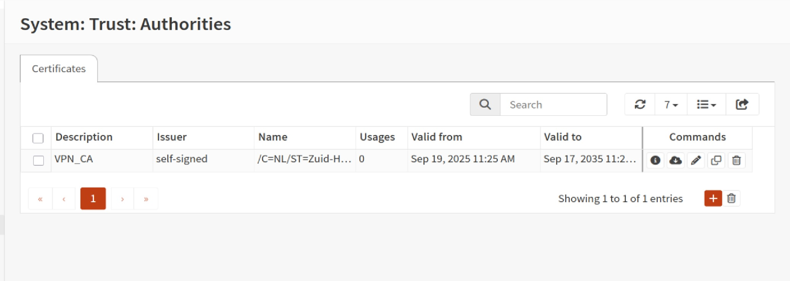

Result: The user can simply import the .ovpn file into any OpenVPN client and connect securely.

# 9. Centralized Logging

At the final stage, centralized logging was set up via UDP/514 using RFC5424 format:  
• Events from firewall, OpenVPN, and IDS are forwarded to an external SIEM.  
• Structured logs (SYSLOG/EVE) ensure clean integration with monitoring tools.

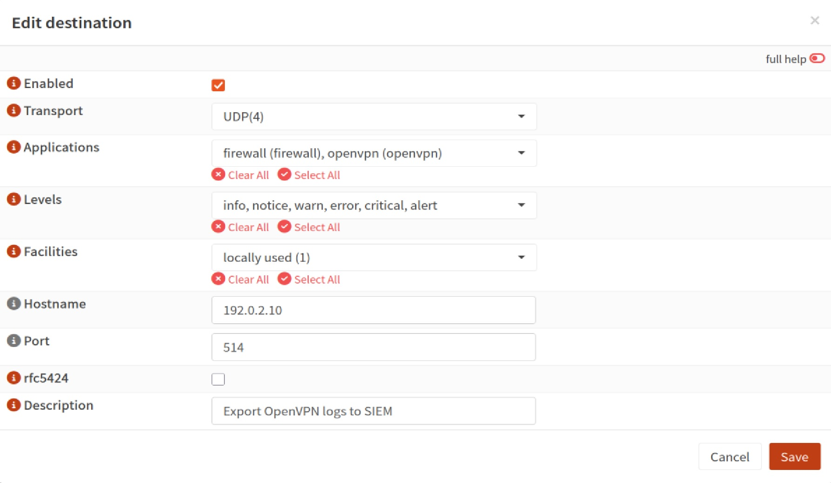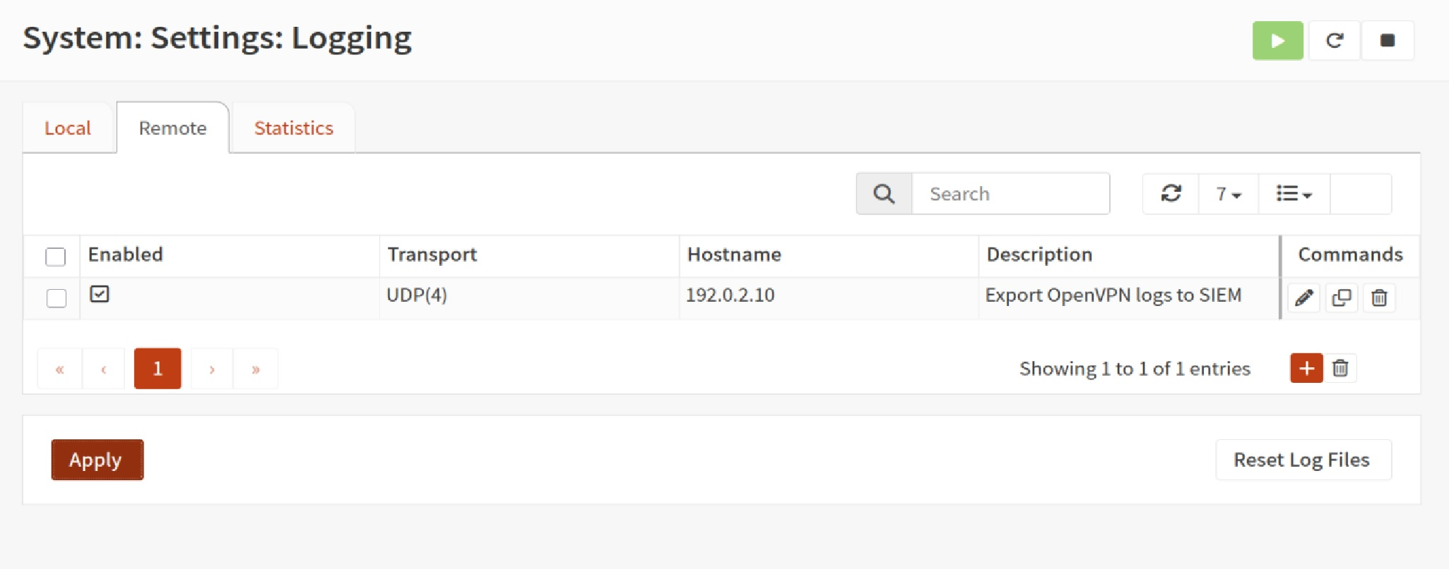

# 10. Final Thoughts

In this project, I built a fully functional and secure network infrastructure from scratch using OPNsense. Here’s what I accomplished:  
• Divided the network into logical zones (LAN, DMZ, MGMT) with isolated access.  
• Set up a clear firewall policy to control traffic between zones.  
• Enabled NAT and DHCP to manage internal devices efficiently.  
• Configured OpenVPN for secure remote access.  
• Deployed Suricata to detect and block threats in real time.

• Implemented centralized logging to track all critical events.